**KSI Insights**

**Report Summary**

The Toronto Police Service database Killed or Seriously Injured (KSI) from 2008 – 2018 was viewed and insights from the data can be obtained by using the software Microsoft Excel and Power BI.

**Data exploration, limitations and assumptions**

Once the data was uploaded into Power BI, the quick insight feature was selected to automatically generate insights from the database.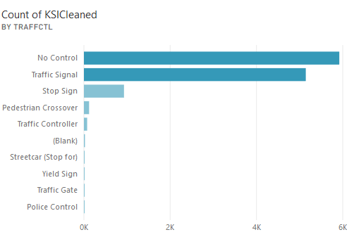 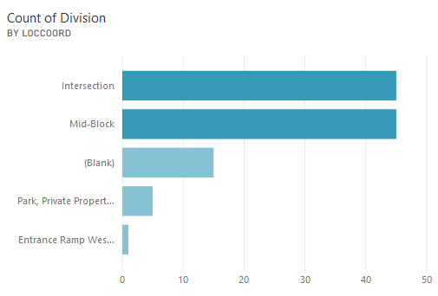

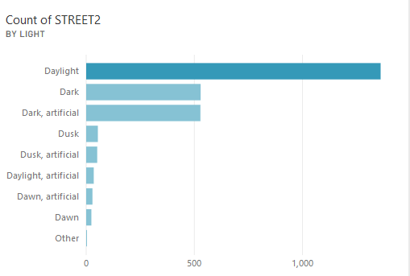

From the charts above, majority of the driving either lost control or not obeying the traffic signal while driving. The locations incidents occurred the most are at the intersections and mid-block. Daylight is when the incident occurs the most.

The most interesting chart discovered is the following.

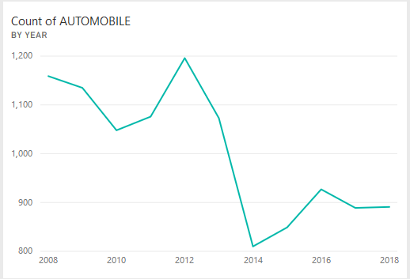



The count of the automobile incident dropped significantly, a count of 263 which is the most from the graph between the year 2013 to 2014. What happened in the year 2013 and 2014 to cause the drastic change? This is the important question.

Graphs below displays similar decreasing counts for other types of incidents.

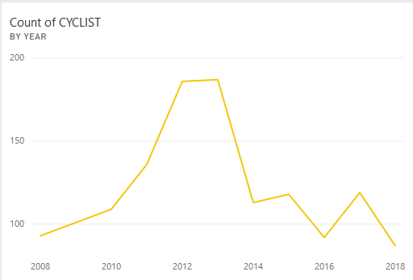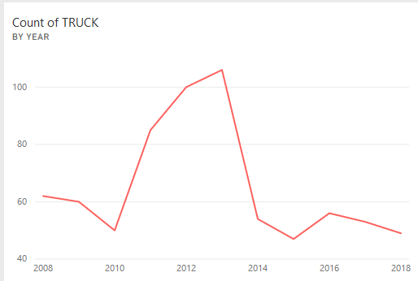



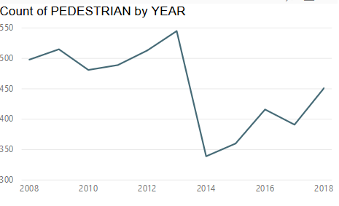



The count of Cyclist decreased 74, truck decreased 52 and 206 for pedestrians. The most decreasing trend for all of them within one year. The mystery of the change which saved hundreds of lives should be known.

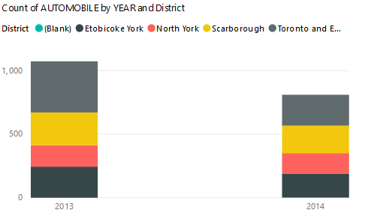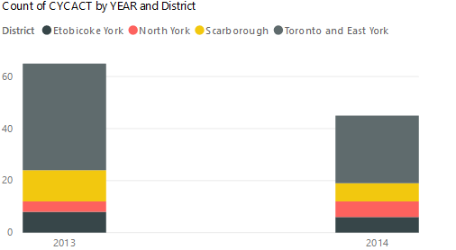

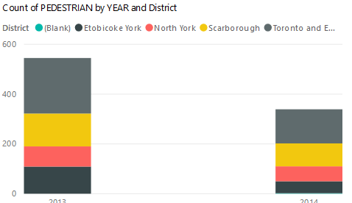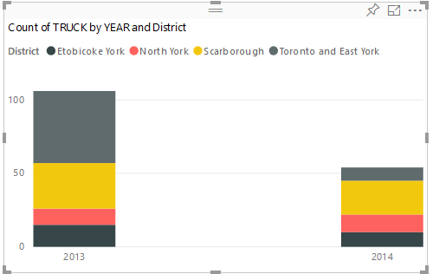

The four graphs above clearly display the district with the largest drops of incident count is at Toronto and East York follow by Scarborough from 2013 to 2014.

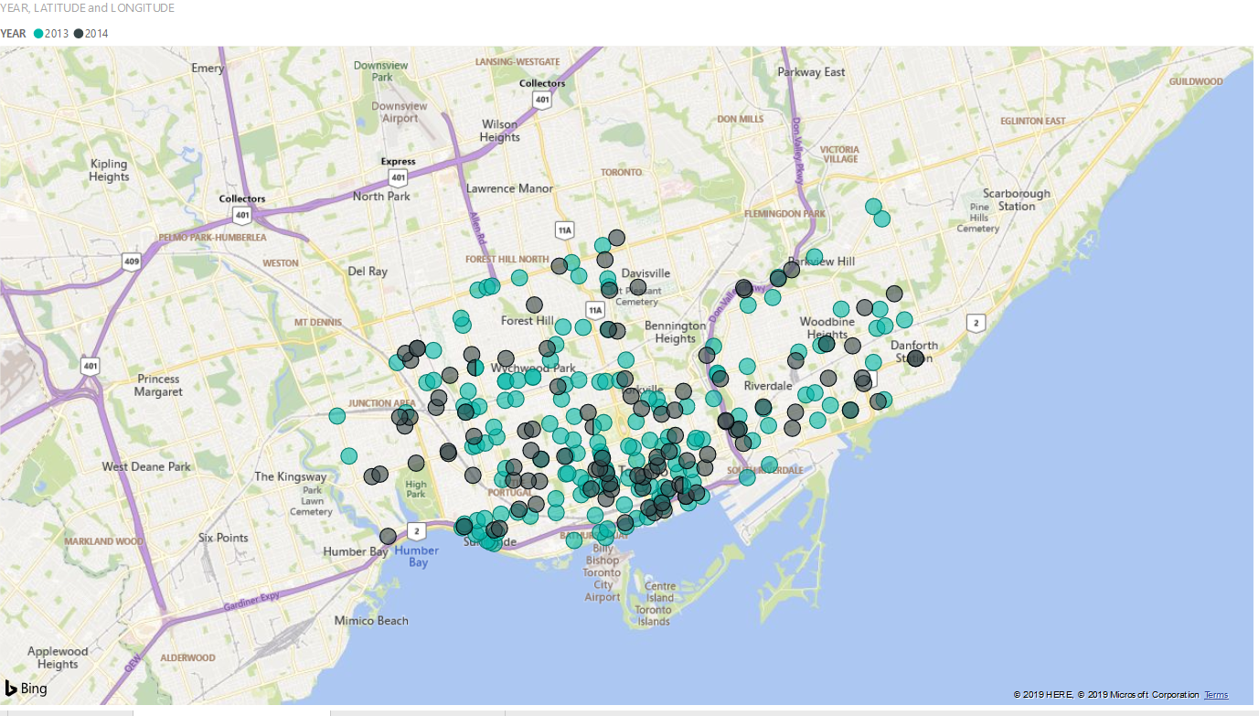

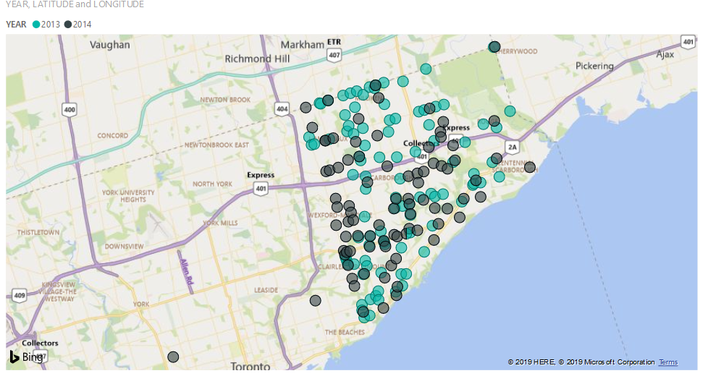

Green circles represent the year 2013 of high incident counts, and black circles are the 2014 low incidents.